EBU6304 Software Engineering Group Project

2025-26
Group number
member 1 | QM no: | Name:
member 2 | QM no: | Name:
member 3 | QM no: | Name:
member 4 | QM no: | Name:
member 5 | QM no: | Name:
member 6 | QM no: | Name:

Final short report

Design
Design strategy
The system was designed as a lightweight web-based Teaching Assistant recruitment management system for BUPT International School. The main design goal was to satisfy the user stories for three roles - Teaching Assistant (TA), Module Organiser (MO), and Administrator (AD) - while keeping the technology stack simple enough for a course project and easy to run on a local machine. Instead of using a heavy web framework or database, the project uses Java built-in HTTP server APIs, JSON file persistence, and static HTML/JavaScript pages. This strategy reduces deployment complexity, makes the system transparent for assessment, and allows each user story to be traced directly to pages, REST endpoints, data files, and tests.
Architectural design
The project follows a simple layered client-server architecture. The frontend layer contains role-specific static pages in the TA, MO, and admin folders. Each page uses shared API helper functions from js/api.js for authentication tokens, HTTP requests, file upload, logout, status badges, date formatting, and common toast feedback. The backend layer is a Java HTTP server started from Main.java. It registers contexts for authentication, jobs, applications, drafts, administration, uploads, notifications, and static file serving. The persistence layer is DataService, which stores and retrieves structured data from JSON files in the data folder and uploaded documents from the uploads folder.
This separation gives the project a clear responsibility boundary. The frontend is responsible for presentation, form interaction, client-side validation, navigation, and local user-experience support such as previewing PDF files and remembering locally generated deadline reminders. The backend is responsible for access control, business rules, data validation, role-scoped queries, and durable data storage. The data layer centralises JSON read/write logic so that handlers do not manipulate files directly.

Implementation
Implementation strategy
The implementation was carried out incrementally according to the user stories and role boundaries. The group first built the core skeleton: Java server startup, static file serving, shared API utilities, JSON data files, and basic login/registration. After that, each role was expanded around its main workflow. For the TA side, the implementation focused on profile management, vacancy browsing, CV upload, application submission, draft saving, status tracking, deadline reminders, and withdrawal. For the MO side, the focus was job posting, job editing, applicant review, CV review, and approval/rejection. For the admin side, the focus was user management, job oversight, workload statistics, audit logs, settings, exports, password reset handling, and system notifications.
The project uses a deliberately simple stack: Java 11+ with com.sun.net.httpserver.HttpServer, Gson for JSON serialisation, static HTML pages with Tailwind CSS via CDN, Iconify icons, and ECharts for statistical pages. The system can be built and run on Windows using build.bat and run.bat. This implementation strategy avoids external application-server configuration and database setup, which is suitable for a short university group project and supports quick demonstration by assessors.
Backend implementation
The backend is divided into handlers that map closely to business capabilities. AuthHandler manages login, registration, profile update, password change, and password-reset requests. JobHandler manages job browsing, job creation and editing, applications to jobs, and retrieval of applications for a job. ApplicationHandler manages role-scoped application listing, application detail, and status transitions such as approval, rejection, and withdrawal. DraftHandler manages server-side TA application drafts so users can continue unfinished applications from another browser session. UploadHandler manages PDF upload and download. NotificationHandler manages user notifications and read status. AdminHandler contains administrative functions such as user management, workload statistics, audit logs, system settings, export tasks, bulk notifications, and password-reset processing.
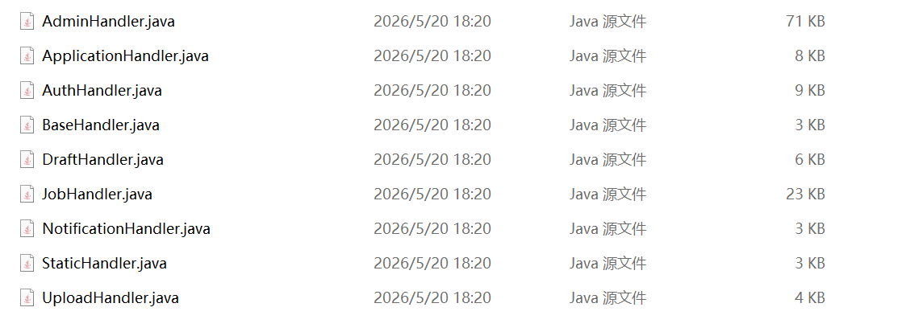
Figure: some of the handlers
The main data models are User, Job, Application, ApplicationDraft, Notification, PasswordResetRequest, AuditLog, ExportTask, and AdminRoleTemplate. These models keep the JSON structure explicit and readable. For example, Application stores the applicant, target job, CV filename, cover letter, status, priority preference, and timestamps. Job stores the job type, course information, quota, schedule, weekly hours, deadline, and type-specific fields for course TA, lab TA, final exam TA, and class test TA work.
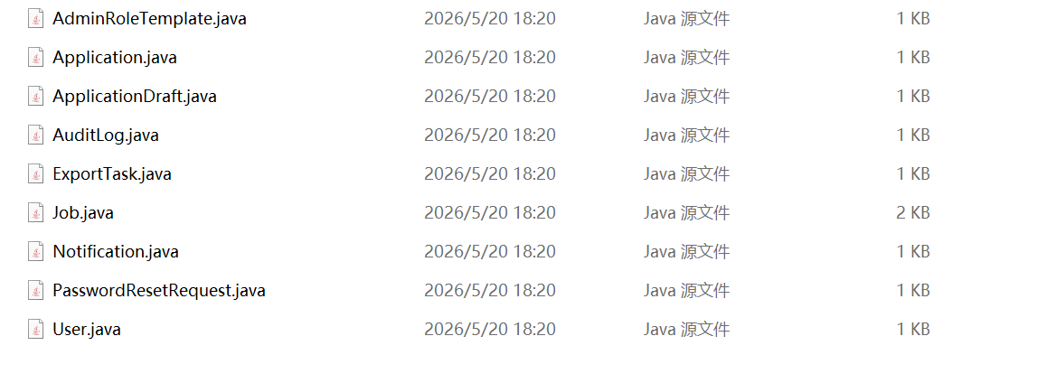
Figure: some of the models
Main.java creates the HTTP server, initialises DataService, registers all API contexts, and starts a fixed thread pool. DataService creates the data and uploads folders if required, seeds default users and demonstration data, manages in-memory sessions, and provides synchronised methods for reading and writing JSON files. The handlers use DataService rather than directly accessing files. This keeps endpoint code focused on HTTP parsing, role checks, validation, and response formatting.
Authentication is token-based. After successful login or registration, DataService creates a session token and the frontend stores it in localStorage. api.js attaches the token to later requests using an Authorization header. The backend authenticate method resolves the token to a User object. Role checks are performed in each handler. For example, only TA users can submit applications and drafts, MO users can only manage their own job postings, and admin-only operations require an ADMIN account. Additional checks are used for sensitive operations, such as password reset approval and user management.
Frontend implementation
From a design perspective, our interface employs a clean card-based layout with clear visual hierarchy and ample white space, which enhances scannability and follows the F-shaped reading pattern. The primary buttons (“Browse Open Positions”, “View positions”) are visually prominent with solid fills, while secondary actions (“View all”) use subtle text links, effectively communicating priority. However, the click targets for these text links are relatively small, which could reduce efficiency per Fitts’s law. The second page’s form lacks a visible submit button (not shown in the snippet), potentially disrupting the user’s mental model of form completion. Additionally, no required-field indicators or inline validation are present, increasing the risk of submission errors. Overall, the layout and labeling are user-friendly, but improving button consistency, enlarging touch targets, and adding submission feedback would further enhance usability.

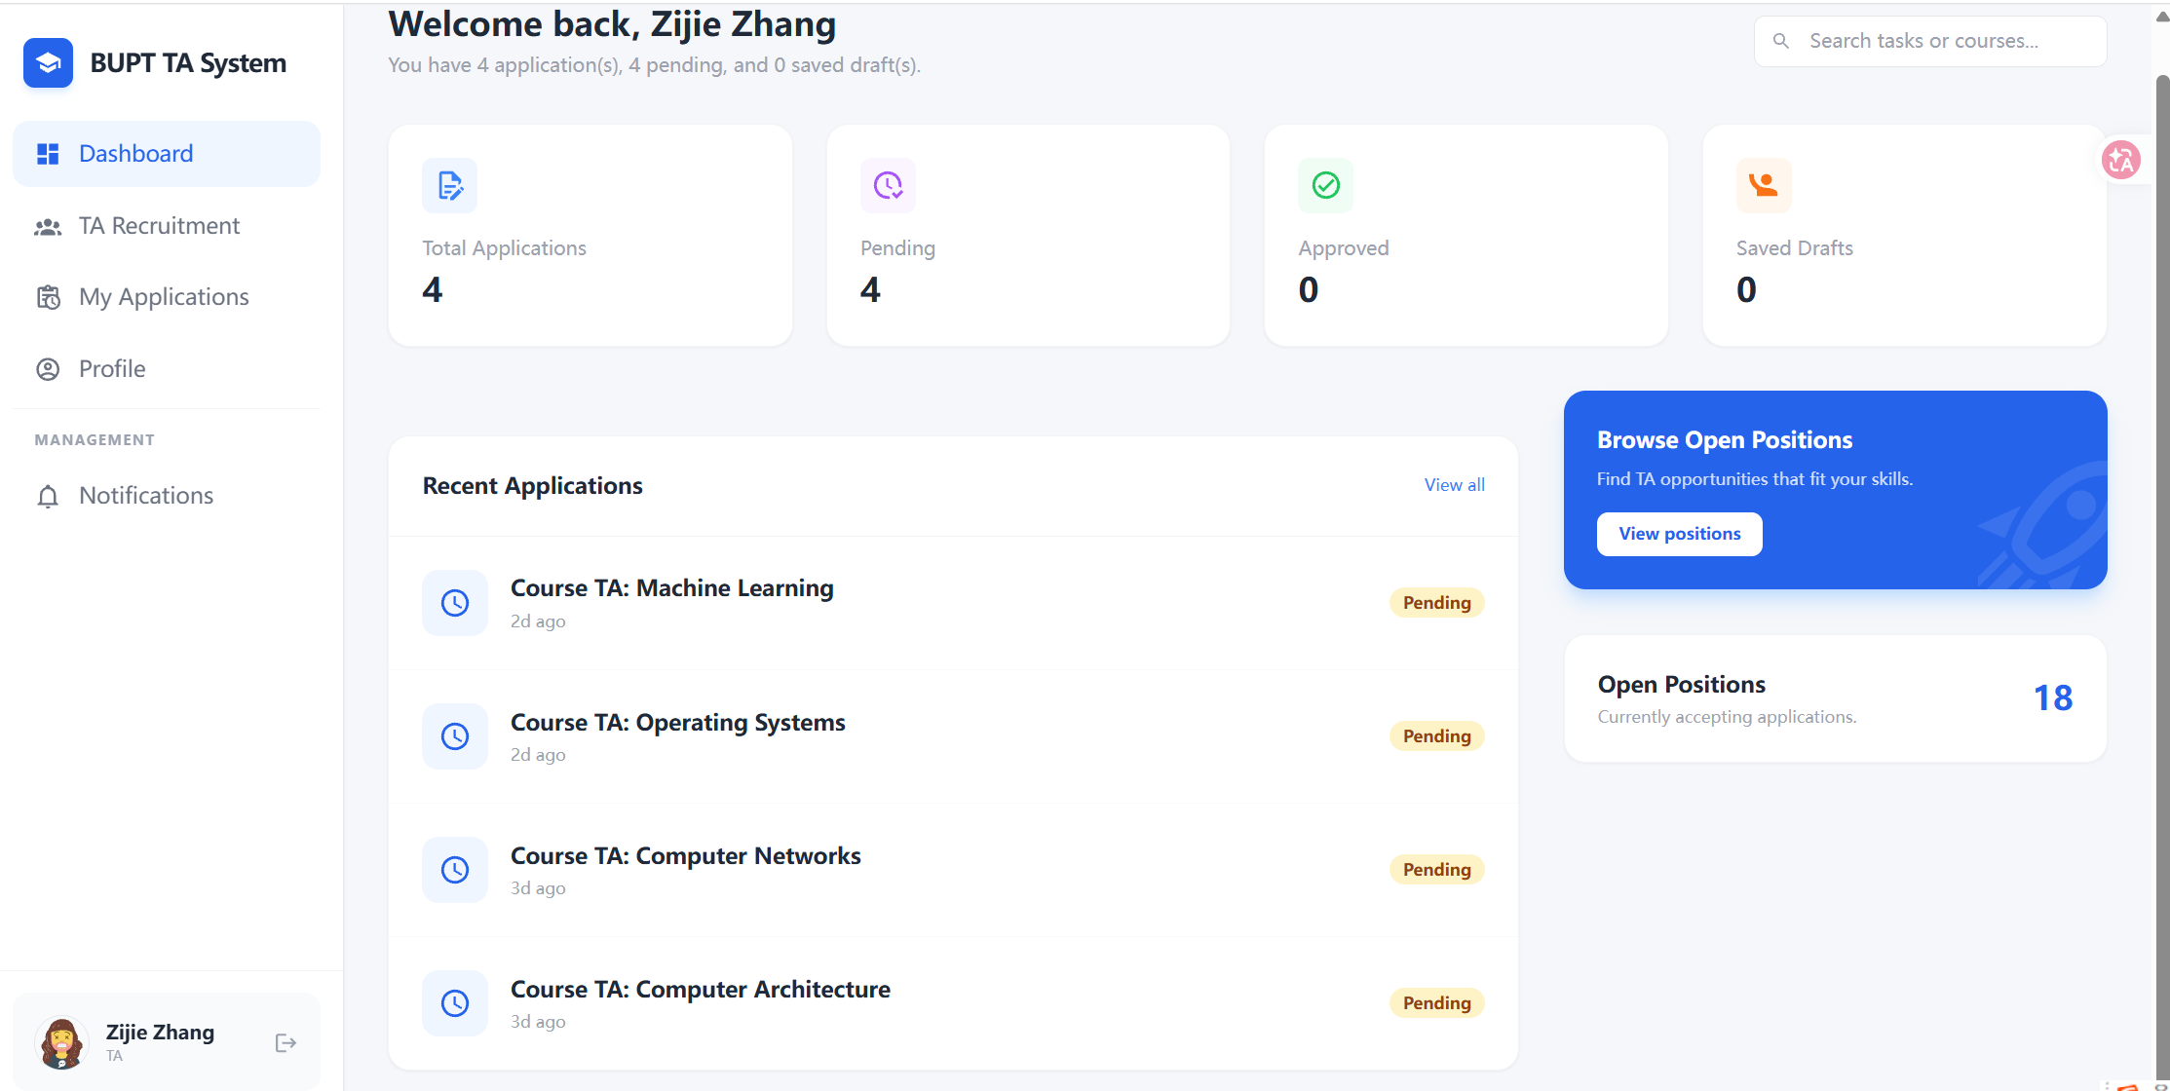
Figure: TA applying for jobs
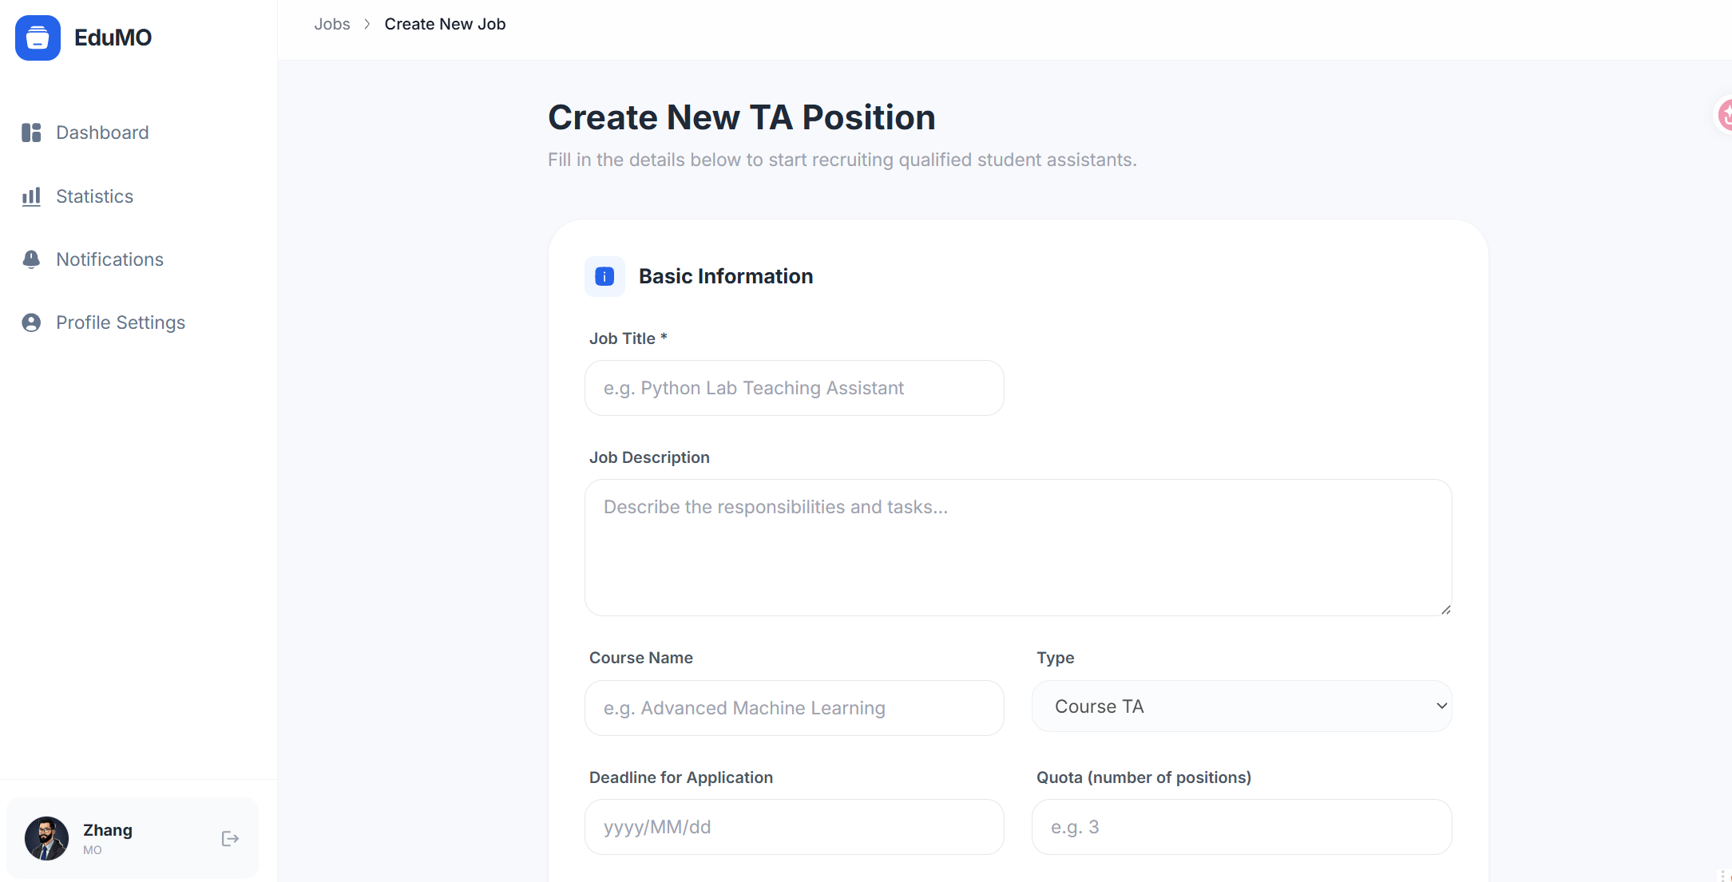
Figure: MO posting new jobs

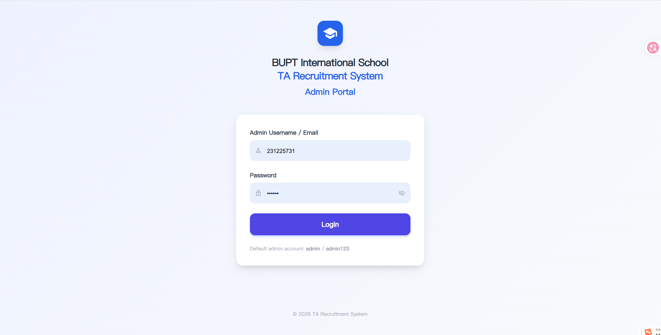
Figure: Admin portal login page
Build plan and deployment
The build plan is intentionally lightweight. The build.bat script compiles model, service, handler, and main Java source files into the out folder using javac with UTF-8 encoding and Gson on the classpath. The run.bat script starts the server and prints the local URLs for the TA, MO, and admin portals. In PowerShell, the scripts are run as .\build.bat and .\run.bat. The default server port is 8080, with an optional custom port argument. Because the frontend is served by StaticHandler from the same project folder, no separate frontend build step is needed.
Version control and collaboration
Git was used to support collaboration and traceability. The project is divided into role-specific directories and backend packages, allowing members to work on TA, MO, admin, handlers, models, and tests with fewer conflicts. Changes were committed incrementally with descriptions tied to user stories, such as draft recovery, upload validation, withdrawal rules, and UI improvements. Version control also helped compare Test_Version_01 and Test_Version_02, preserve a working baseline, and review later refinements before merging. Generated files and runtime data need careful handling because JSON demo data and compiled class files can change after running or building the project; this was considered when preparing commits.
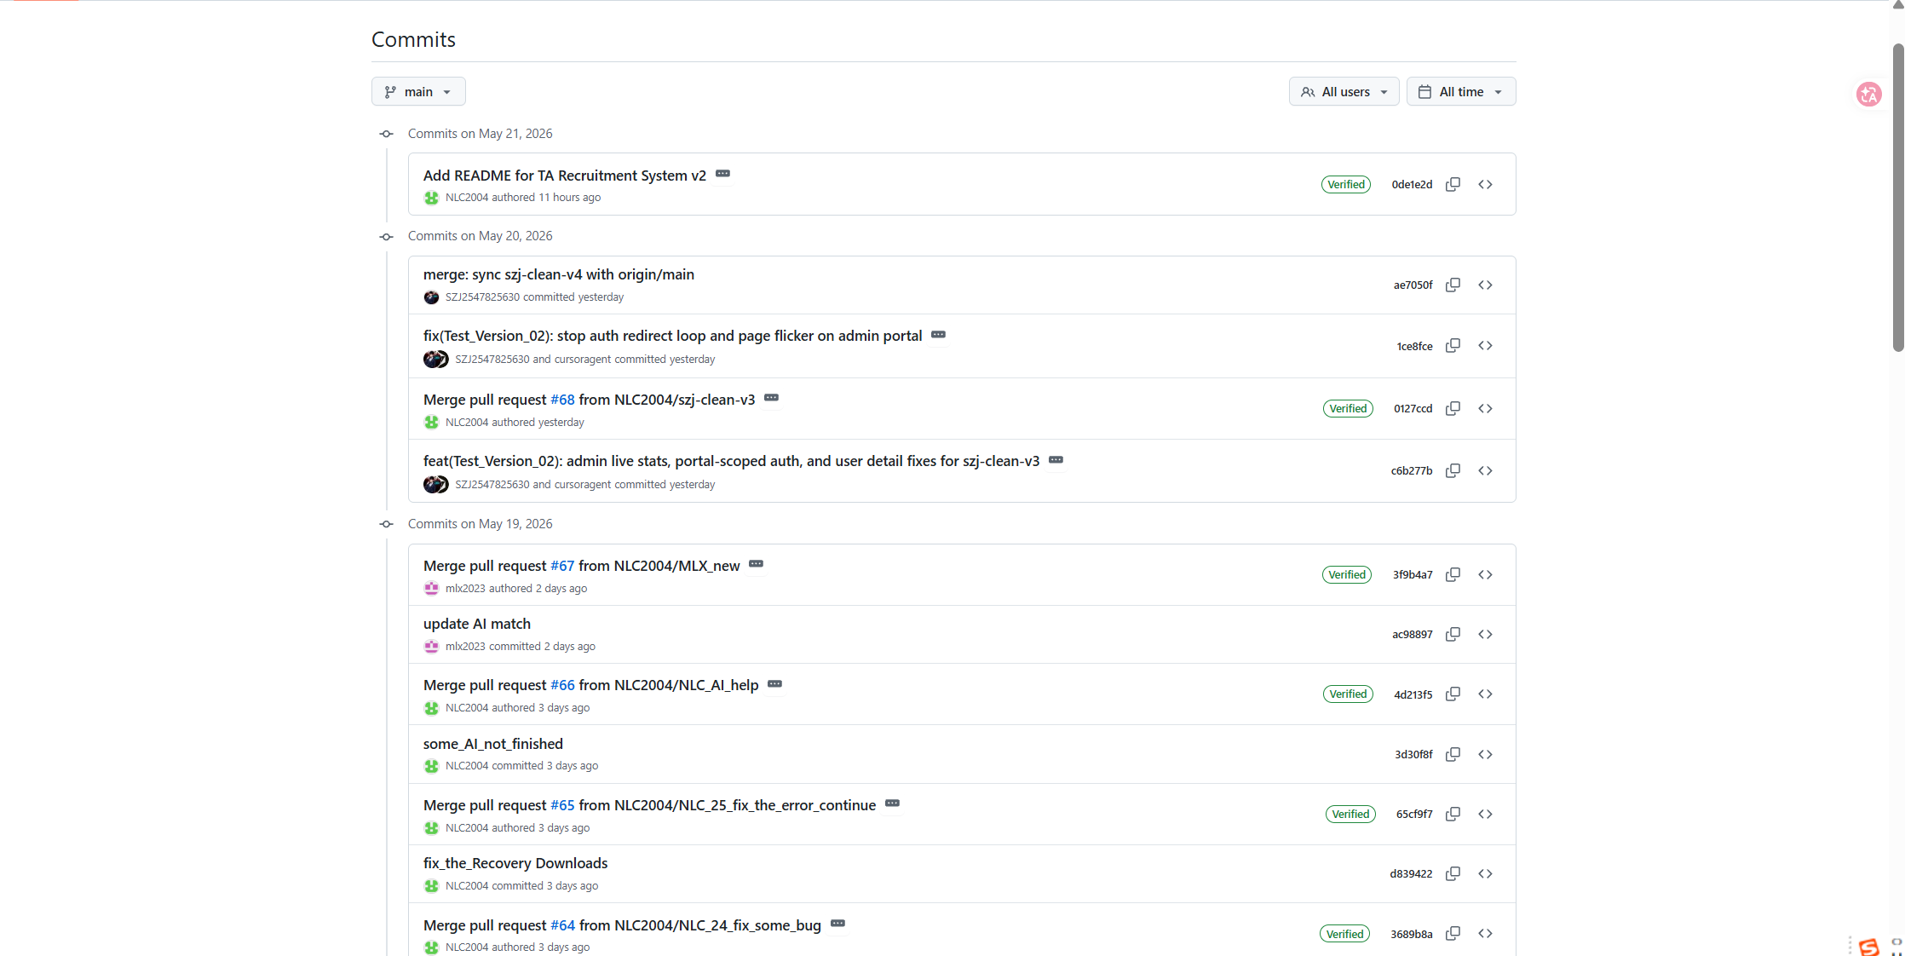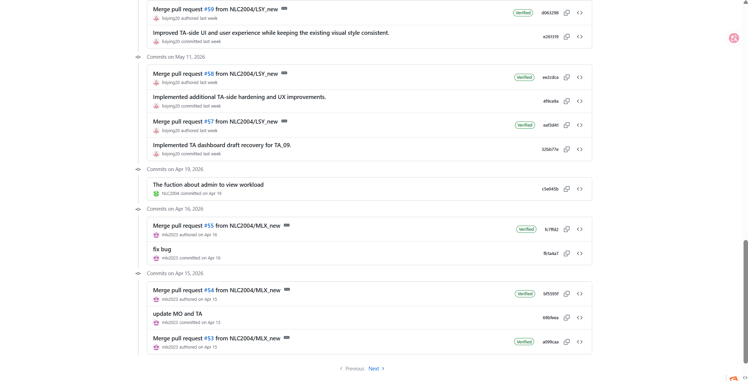
Figure: update the version consistantly

Testing
Unit testing
We conducted unit testing by simulating three distinct roles—instructor, teaching assistant, and administrator—across the system’s core modules. Each role was assigned a dedicated test account to verify that permissions, workflows, and interfaces behave as expected. For instructors, we focused on creating TA positions, setting deadlines, and reviewing applicants. For TAs, we tested application submission, document uploads, and viewing assignment status. For administrators, we validated notification broadcasting, quota management, and overall dashboard statistics. By isolating each module (e.g., job creation, application list, profile updates) and executing role-specific operations, we uncovered several edge cases: a TA could accidentally edit a submitted application before the deadline; an instructor saw pending counts that did not refresh in real time; and an admin’s quota change failed to trigger a warning when overbooked. These unit tests confirmed that while basic CRUD functions worked, cross-role data synchronization and real-time updates needed refinement. This role-based simulation approach proved efficient—it allowed us to catch permission leaks and workflow gaps early, ensuring that the final interface remains both secure and user-friendly for all stakeholders.
Overall, the testing strategy improved the reliability of the system by connecting user stories to executable tests. It also supported safe refactoring and UI improvement: after enhancing TA pages, backend compilation and TA regression tests confirmed that the core behaviour remained stable.

The use of Generative AI (GenAI)
Describe the GenAI tool(s) used at different stages of the software development process. Critically evaluate their effectiveness in supporting development activities and discuss their limitations and challenges.
To here - No more than 10 pages including tables, charts, figures and diagrams you may have.

Individual contribution and reflection
Each group member should provide one paragraph outlining their key contribution to the project (this must be agreed by the group) and another paragraph reflecting on their learning experience (this should include thoughts on the overall process, challenges encountered, and skills developed). Maximum 300 words for each member. Copy the template below.
QM no:
Name:
Main contribution:
Reflective statement:

